Wanneroo Secondary College
Year 12 Mathematics Specialist Unit 4
Test 5 2019
Calculator-Free Section

You are only allowed the SCSA formula sheet for this section. Any question worth more than 2 marks requires sufficient working to justify your solutions.
Time : 20 Minutes Marks : 17

1. [2, 3 = 5 marks]
A particle moves with velocity $v=2\sqrt{x} ms^{-1},$ where $x$ is it’s displacement. The particle is initially 2 m to the right of the origin.

a) Show that the particle has constant acceleration

b) Determine the displacement, $x$, as a function of time, $t$.

2. [1, 2, 4 = 7 marks]
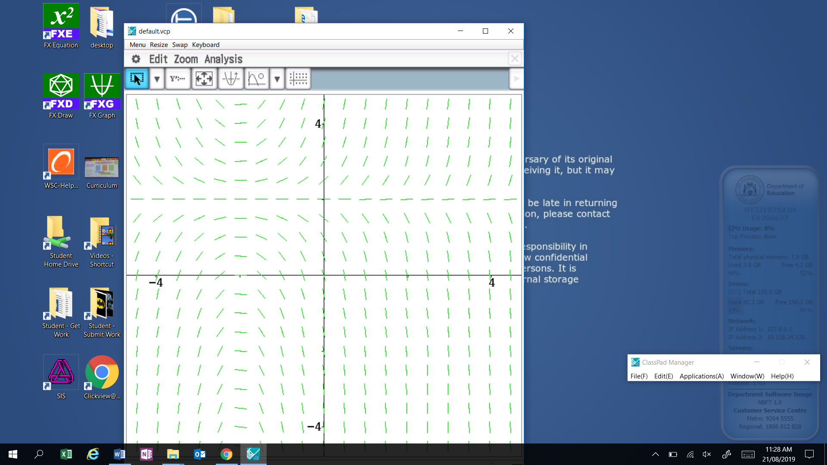
a) Circle the differential equation that best matches the slope field shown:
i) $\frac{dy}{dx}=\frac{2-x}{y-2}$ ii) $\frac{dy}{dx}=$ $(x+2)(y-2)$

iii) $\frac{dy}{dx}=\frac{2+x}{y+2}$ iv) $\frac{dy}{dx}=(x-2)(y+2)$

b) Determine the value of the slope field at the point (2, 3) and draw the solution on the slope field above.

c) Determine the equation of the particular solution curve that passes through the point (2, 3)

3. [5 marks]
Determine the gradient of the tangent to the curve $\frac{2x^{3}-y^{2}}{xy}=1$ at the point (1, 1)

Wanneroo Secondary College
Year 12 Mathematics Specialist Unit 4
Test 5 2019
Calculator-Assumed Section

You are allowed the SCSA formula sheet, approved calculator(s) and one page of A4 notes (back and front) for this section. Any question worth more than 2 marks requires sufficient working to justify your solutions.

Time : 35 Minutes Marks : 33

4. [3, 2 = 5 marks]
After $t$ seconds, the displacement $x$ centimetres of a small mass attached to a spring, oscillates about a fixed point $O$ according to the differential equation $\frac{d^{2}x}{dt^{2}}=-25x cms^{-2}$.
The initial velocity is 15 centimetres per second and the initial displacement is zero.
a) Determine the function $x(t)$ that gives the displacement of the mass at time $t$

b) Calculate the distance the mass travels during the first 3 seconds.

5. [2, 3 = 5 marks]
A dog’s drinking bowl is formed by revolving the curve $y=\frac{1}{10}x^{2}$, $0≤x≤10$, through 360$°$ about the y-axis. The units of $x$ and $y$ are in centimetres.
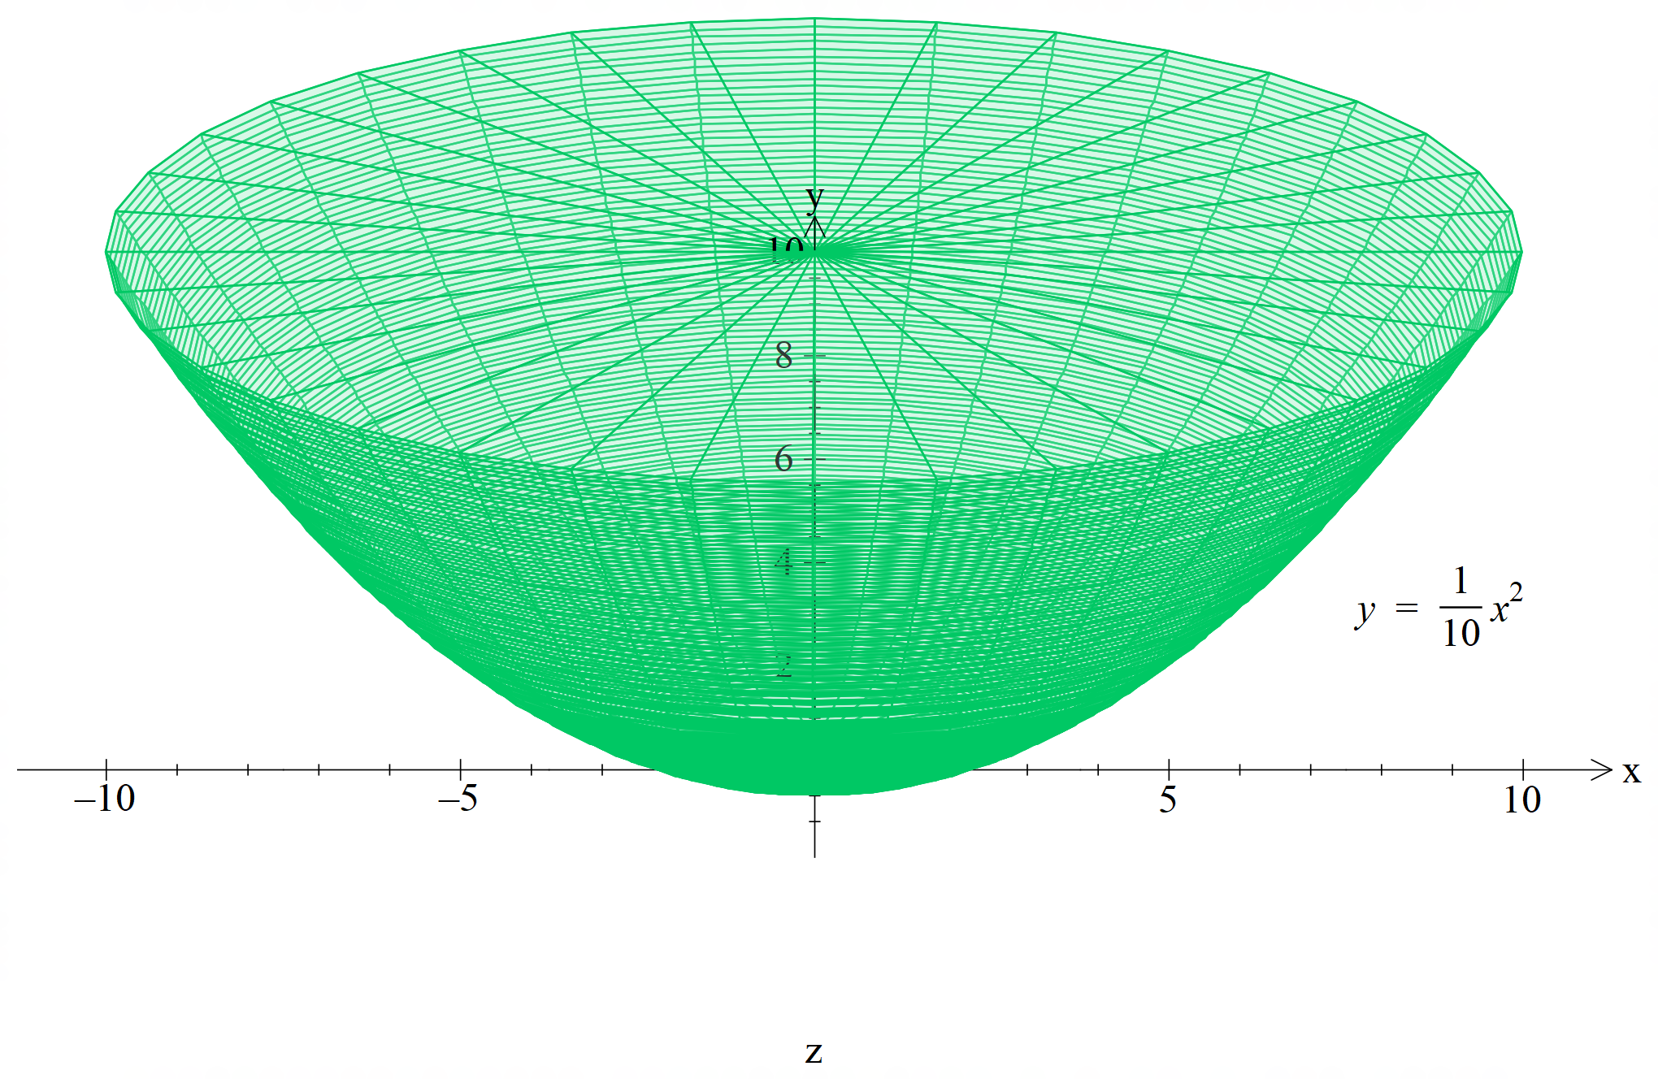

a) Show the expression connecting the height $h$ of water in the bowl and the volume $V$ of water in the bowl is given by $V=5πh^{2}$

b) The bowl is filled with water at a rate of 50mL per second. At what rate is the height of the water increasing at the time when the bowl contains 600 mL of water?

6. [7 marks]
Determine the values of the constants $a$ and $b$ if $y=e^{4x}(2x+1)$ is a solution of the differential equation $\frac{d^{2}y}{dx^{2}}-a \frac{dy}{dx}+by=0$

7. [6, 4 = 10 marks]
An ecology student is studying the repopulation of wild emus in Western Australia after a drought. She notices that the population growth rate is approximately logistic so that $\frac{dP}{dt}=kP\left(1-\frac{P}{A}\right)$ where $P\left(t\right)$ is the population $t$ years after her study begins.
The carrying capacity $A$ is known to be 2550 emus, since this was the population before the drought.
Initially, the student finds that there are 310 emus. After 2 years she finds there are 390 emus.
a) Given that $\frac{1}{P(2550-P)}=\frac{1}{2550}\left(\frac{1}{P}+\frac{1}{2550-P}\right)$ , use the separation of variables technique to determine the equation to find the population $P(t)$ after $t$ years

b) Find the time at which the population growth rate is a maximum.

8. [3, 3 = 6 marks]
The graph of ${\left(x^{2}+y^{4}-2\right)}^{3}=8x^{2}y^{5}$ is shown below:
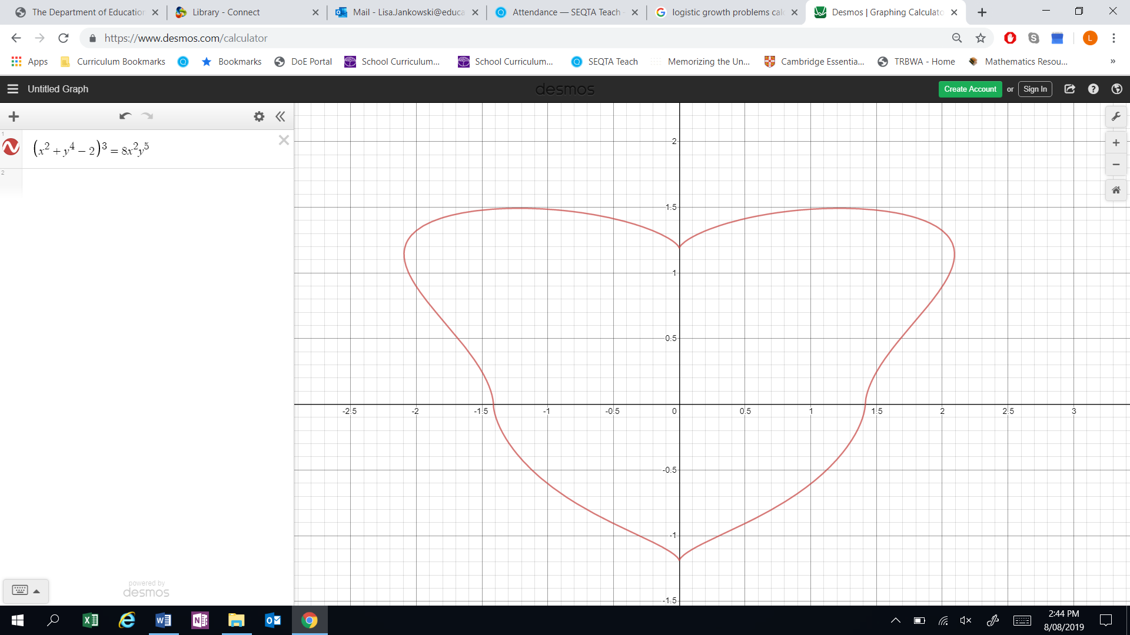

a) By implicitly differentiating the given equation, obtain an equation relating $x, y$ and $\frac{dy}{dx}$.
Note: Do not attempt to obtain $\frac{dy}{dx}$ as the subject of this equation.

b) Determine the coordinates of the point on the graph in the first quadrant ($x>0 and y>0\}$ where the gradient is horizontal.

